RESOLUTION NO.__________

RE: CERTIFICATE OF APPROPRIATENESS UNDER THE
PROVISIONS OF THE ACT OF THE PENNSYLVANIA
LEGISLATURE 1961, JUNE 13, P.L. 282 (53
SECTION 8004) AND BETHLEHEM ORDINANCE NO.
3952 AS AMENDED.

WHEREAS, it is proposed to replace trim and windows and to repaint brick, stucco, foundation, wood cornice, brackets, storefronts, windows, window frames, sills, chimneys and entrance ceilings at 559 Main St.

NOW, THEREFORE, BE IT RESOLVED by the Council of the City of Bethlehem that a Certificate of Appropriateness is hereby granted for the proposal.

Sponsored by: (s)

(s)

ADOPTED BY COUNCIL THIS DAY OF

(s)
President of Council

ATTEST:

(s)
City Clerk

HISTORICAL & ARCHITECTURAL REVIEW BOARD
The applicant proposes to replace trim and windows and to repaint brick, stucco, foundation, wood cornice, brackets, storefronts, windows, window frames, sills, chimneys and entrance ceilings at 559 Main St.

APPLICATION #3:

Rubel Street, L.P.
559 Main St., Suite 300
Bethlehem, PA 18018
OWNER:

__________________________________________________________________

The Board upon motion by Connie Glagola and seconded by Marsha Fritz adopted the proposal that City Council issue a Certificate of Appropriateness for the following:

1. Replace windows with new Pella Architect Series wood sash 7/8” simulated
divided lights.

2. The trim to match wood profiles and include new cap flashings on window heads
and storefront cornices.

3. Rail and style sizes will match as well as the exterior colors.

4. The motion was unanimously approved.
__________________________________________________________________________

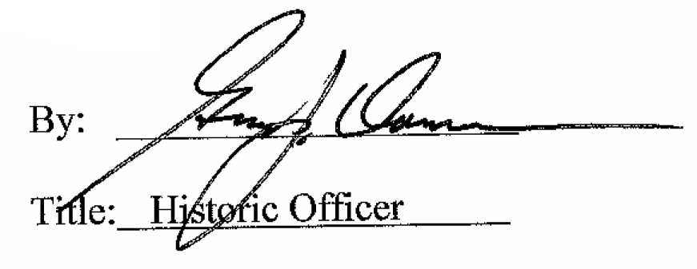

Date of Meeting: July 6, 2016

